Tutorial 6.1: Performance Testing
In this tutorial, you will be researching various tools on performance testing. You will also explore several tools such as PageSpeed, timeit() in Python and JMeter to understand how these tools work.
A. Performance and Load Testing
- Give a brief description on the definition of performance and load testing. Explain the importance of such test.

- Research at least 3 different software tools you can use for performance and load testing. Provide a brief writeup on the selected tools and make a table of comparison for the selected tools.

B. Performance test using PageSpeed
PageSpeed Insights (PSI) reports on the performance of a page on both mobile and desktop devices, and provides suggestions on how that page may be improved.
More information can be found at https://developers.google.com/speed/docs/insights/v5/about
Go to https://pagespeed.web.dev/ and test 3 different websites.
Tabulate your results and briefly write down your findings.
Also include what can be done to improve the scores for the chosen websites.

C. Performance test using Python timeit
Python timeit() can also be used to measure the performance of your code. It is a method in Python library to measure the execution time taken by the given code snippet. The Python library runs the code statement 1 million times and provides the minimum time taken from the given set of code snippets. Python timeit() is a useful method that helps in checking the performance of the code.
Syntax: timeit.timeit(stmt, setup,timer, number)
Parameters:
- stmt: This will take the code for which you want to measure the execution time. The default value is “pass”.
- setup: This will have setup details that need to be executed before stmt. The default value is “pass.”
- timer: This will have the timer value, timeit() already has a default value set, and we can ignore it.
- number: The stmt will execute as per the number is given here. The default value is 1000000. This executes the setup statement once, and then returns the time it takes to execute the main statement a number of times, measured in seconds.
To install timeit,
pip install pytest-timeit
Example 1:
Code:
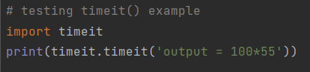
Output:
This means the execution time for the code ‘output = 100 x 55’ is 0.014296899999999994.

Another way to find the execution time for a certain function is shown below:
Example 2:
Code:
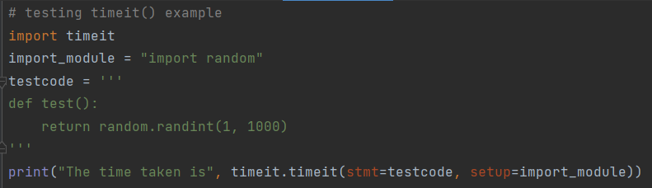
Output

- You can change the default value of number from 1 million to 1000
Output:
.
- You can also repeat the process for 5 times
Output:

Task:
You are given the following python code
mylist = [x for x in range(10000)]
find = randint(0, len(mylist))

- You are to use timeit() to
  - Find the time it takes to run the above code
  - Find the time it takes for 3 repetitions
  - Find the minimum time it takes for 5 repetition and with number = 5,000,000.

- (Optional) Your task is to compare the time it takes for linear and binary search algorithms to find the random integer ‘find’ in mylist. You can read about search algorithms and their codes in: https://stackabuse.com/search-algorithms-in-python/
- use repeat = 1 and number = 1000
- use repeat = 3 and number = 10000, only show the minimum of the 3 repetitions
- use repeat = 5 and number = 20000, only show the minimum of the 5 repetitions
Tabulate your result in the table below:
repeat | number | Linear | Binary
1 | 1000
3 | 10000
5 | 20000

D. Performance testing using JMeter
Overview
In this exercise, you will use Apache JMeter, a Java based application used to test performance of static and dynamic resources. JMeter was originally developed to test the Apache server, but it has been extended to test various applications. JMeter can simulate heavy loads on a server, multiple requests and provides a variety of reporting options, which can be used to analyse performance.

Tests in JMeter are designed using a GUI and are organized in a tree structure, that defines the hierarchies and order of operations. A Test Plan consists of the following elements: ThreadGroup, Controller, Samplers, Listeners, Pre-Processors and Post-Processors. By arranging the available elements and using appropriate parameters, you can run complex tests to find out about the performance of a server or application.

Installation and Setup
- Java is required before you can use JMeter. You can download Java from https://www.java.com/en/download/ if you are using Windows or https://www.java.com/en/download/apple.jsp if you are using Mac.
- Download JMeter from the website:
https://jmeter.apache.org/download_jmeter.cgi.
Select under Binaries > apache-jmeter-5.5.zip
- After downloading, decompress the folder.
Go to the unzip folder > bin > ApacheJMeter.jar and you should see JMeter starting up.

Getting Started
- Read the following section of the manual to familiarize yourself with JMeter:
http://jakarta.apache.org/jmeter/usermanual/build-test-plan.html
- Start JMeter by running: jmeter.bat in Windows or jmeter in Unix.
- The User guide for JMeter is available at: http://jakarta.apache.org/jmeter/usermanual/index.html
- Video tutorial:
https://www.youtube.com/watch?v=mXGcBvWYl-U
https://octoperf.com/blog/2018/03/29/jmeter-tutorial/#view-results-tree

Some screenshots are shown below to demonstrate the basic usage of JMeter:

- Creating a Test Plan
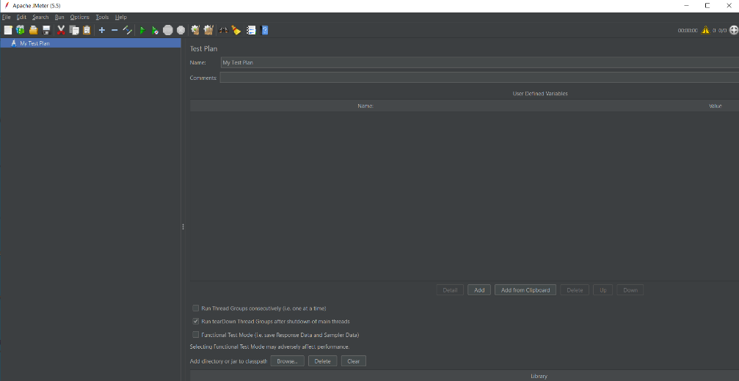

- To add a thread group, right click on My Test Plan > Add > Threads(Users) > Thread Group. Thread group is the basic element of the Jmeter Test plan. As said in the name Thread group is a group of threads that are executing the same scenario. This is considered the beginning point of a test plan.

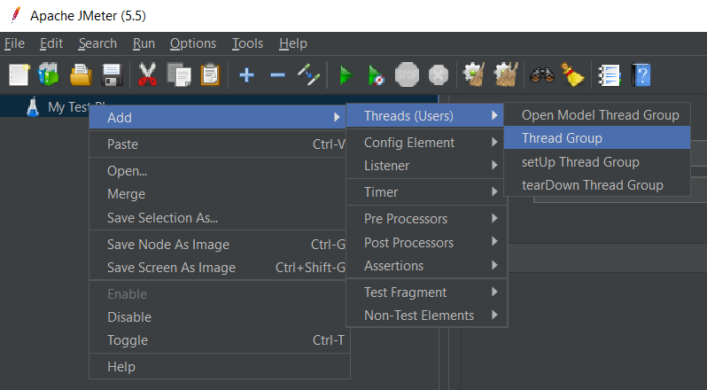

- Specifying details in the thread group:
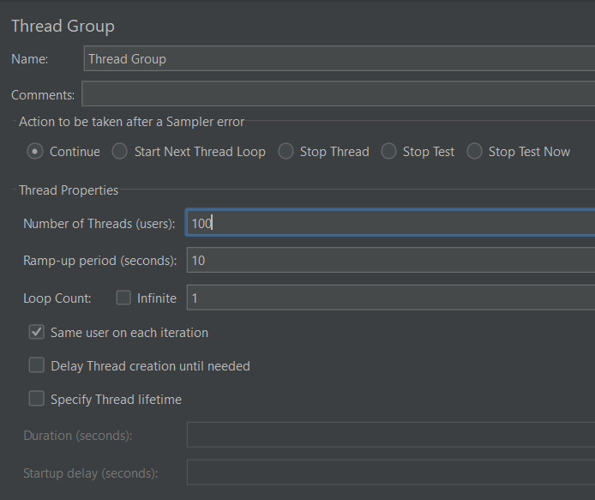

- Adding constant timer. Timers are used to delay JMeter sending next request. If there are no timers, JMeter will send next request in fractions of seconds. Constant Timers are used to delay the next request by a constant time which you can configure by adding the value of constant delay time. Right click on thread group > add > timer > constant timer.

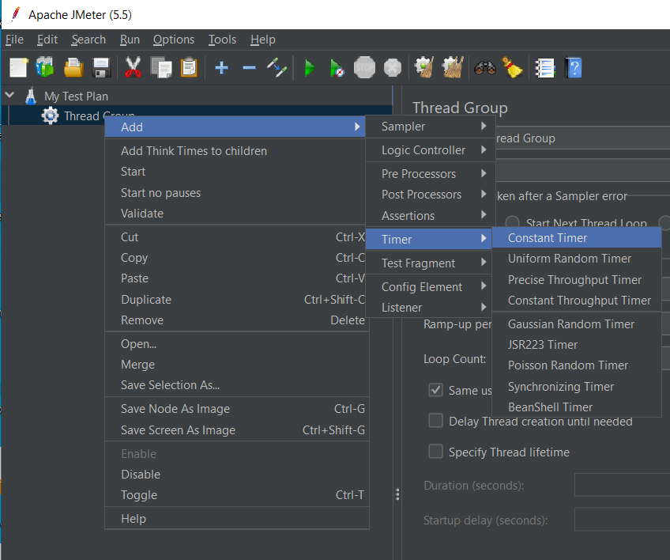

Setting the delay in constant timer.
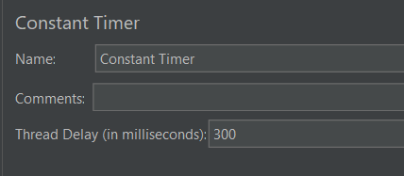

- Adding HTTP Request Sampler. Samplers in JMeter allows JMeter to send different types of requests to a server. Samplers are the actual requests, JMeter sends to the web server under test. HTTP Request is a sampler that lets you send an HTTP/HTTPS request to a web server for load testing. Right click on thread group > add > sampler > HTTP request.

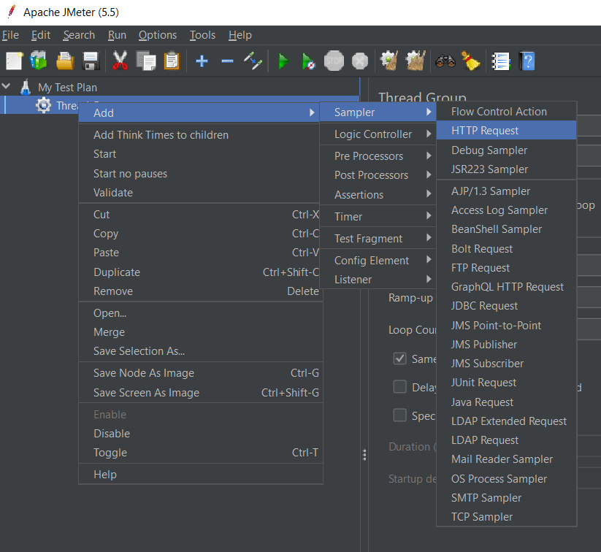

Specify the website that you want to perform load testing.
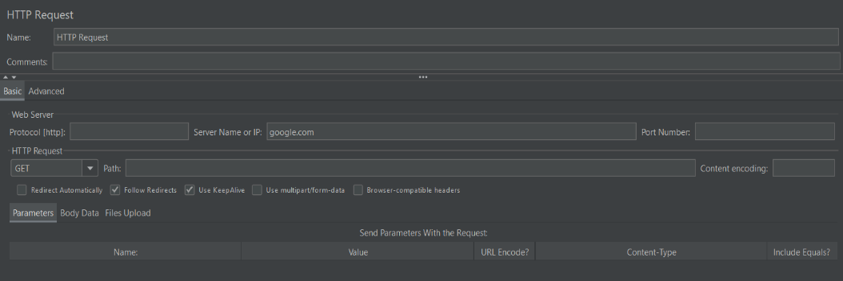

- Adding a listener. A listener is a component that shows the results of the samples. The results can be shown in a tree, tables, graphs or simply written to a log file. Right click on HTTP request > add > listener > graph results .

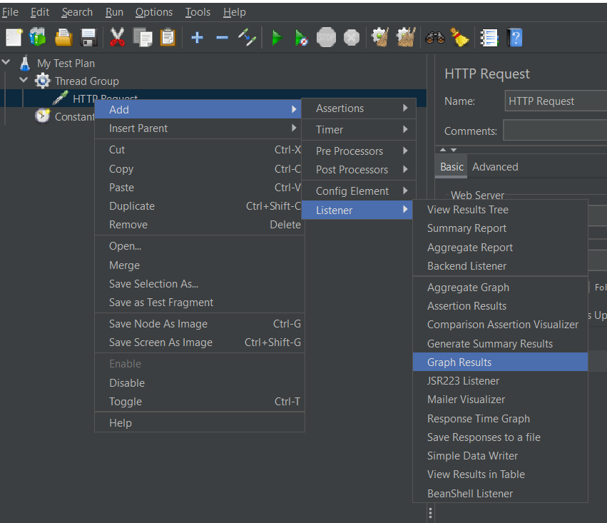

You can add multiple listeners. Then press start to perform the HTTP request to the server.
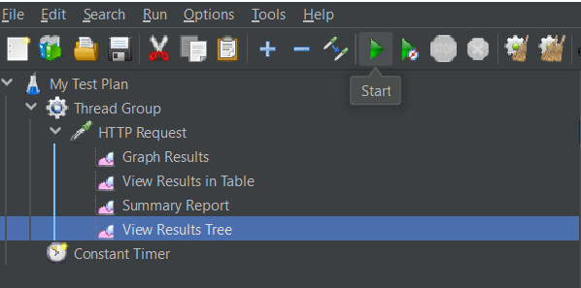

You can then view the various results.

  - Graph Results
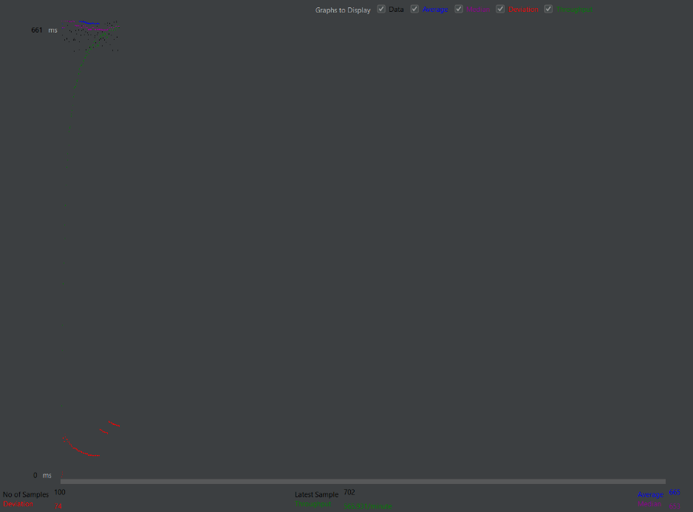

  - View Results in Table
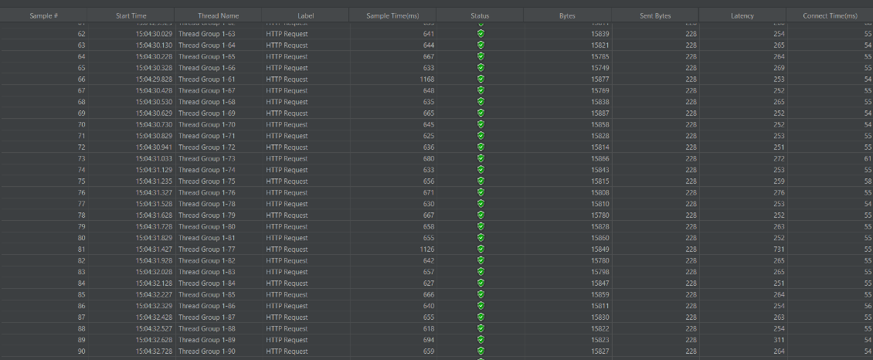

  - Summary Report

  - View Results Tree
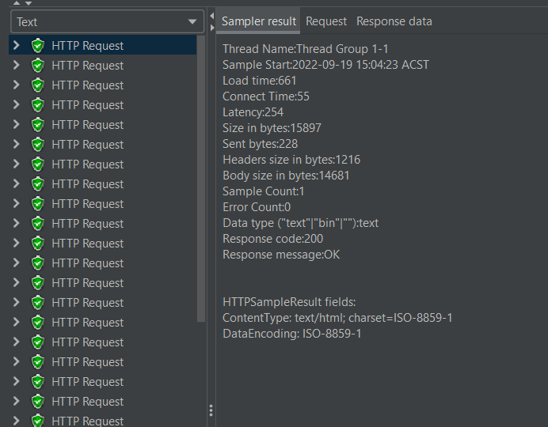
Tasks:

- Basic tests to http servers
  - Create a new test plan
  - Add a Thread Group with 100 threads, and a Ramp-Up period of 5 seconds and Loop Count of 2.
  - Add a Timer (Constant) of 300 ms
  - Add a http request sampler to your Thread Group and use blazedemo.com as the server name
  - Add the Graph Results and View Results in Table listeners to your test
  - Run the test and save the results to a file

Repeat the tests for the following sites:
- https://petstore.octoperf.com/
- https://demo.borland.com/InsuranceWebExtJS/

  - Produce a summary report showing the statistics for each site (Site name vs. average statistics).
Websites | Throughput/min | Average/ms | Deviation/ms | Latency/ms
Blazedemo.com
petstore.octoperf.com
demo.borland.com/InsuranceWebExtJS/

- Testing with different loads
  - Create a new test plan
  - Repeat Part C but with different number of threads only to blazedemo.com
- 500
- 1000
- 2000
  - Make a summary table that compares the average performance(ms) for different number of threads.

No. of Threads | Throughput/min | Average/ms | Deviation/ms | Latency/ms
500
1000
2000

- Testing Performance using parameters
In this section, we will be accessing the performance for different flights.
Go to https://www.blazemeter.com/blog/jmeter-tutorial for more details
- Add a Thread Group with 1000 threads, a Ramp-Up period of 5 seconds and Loop Count of 1 to a new Test Plan
- Add a constant timer of 300 ms
- Add a http sampler to your Thread Group and use blazedemo.com as the server name and the path to /reserve.php
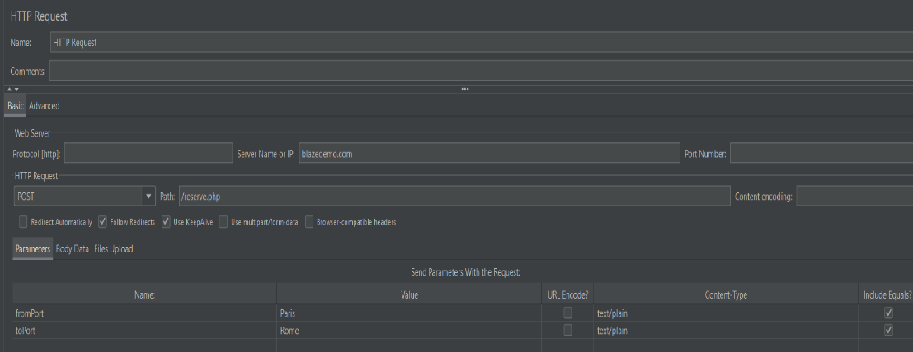

- Repeat the experiments using the following parameter value for the departure and destination city:
- Paris to Rome
- Mexico City to New York
- San Diego to Dublin

- Make a summary table that compares the average performance(ms) for each journey.

Journey | Throughput/min | Average/ms | Deviation/ms
Paris to Rome
Boston to London
Portland to Dublin

- Useful Resources
You may want to explore the following resources to help you further your understanding on JMeter.
- https://www.blazemeter.com/blog/jmeter-tutorial
- JMeter Browser Recording Tutorial https://www.youtube.com/watch?v=zYAiBwJK1v8
- https://octoperf.com/blog/2018/03/29/jmeter-tutorial/#dynamic-parameters
- JMeter Tutorial For Beginners https://www.youtube.com/watch?v=mXGcBvWYl-U

